**Counter Program Assignment**

***Tabitha Wanjiru Muhiukia***

1. **Index_CounterProgram.html**

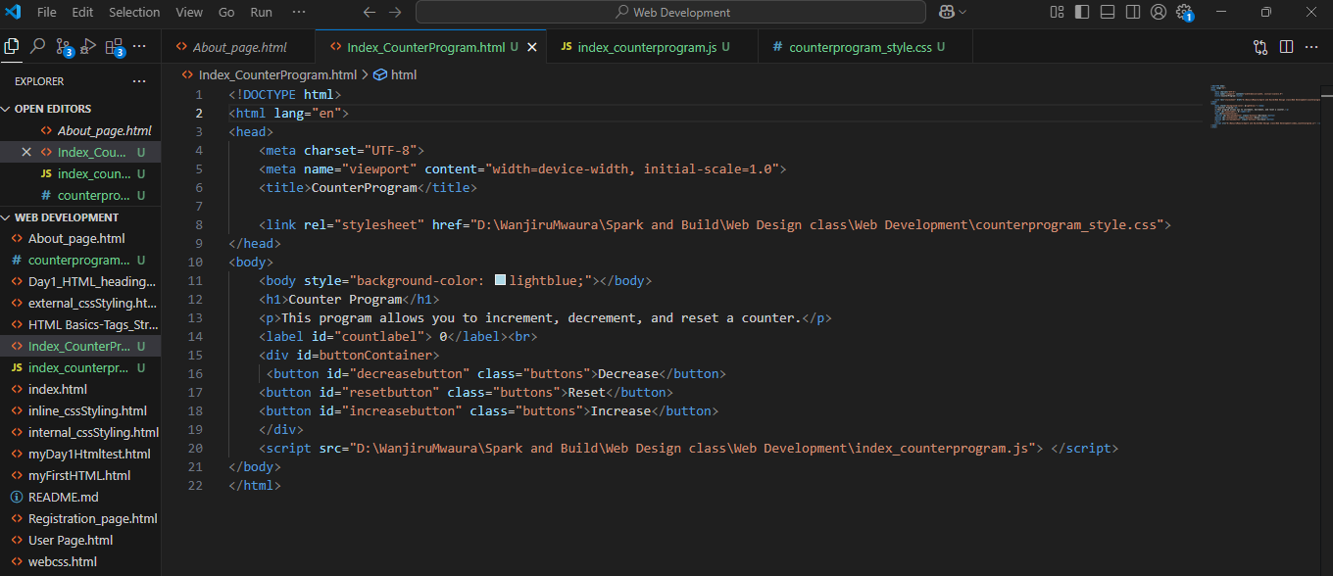

1. **counterprogram_style.css**

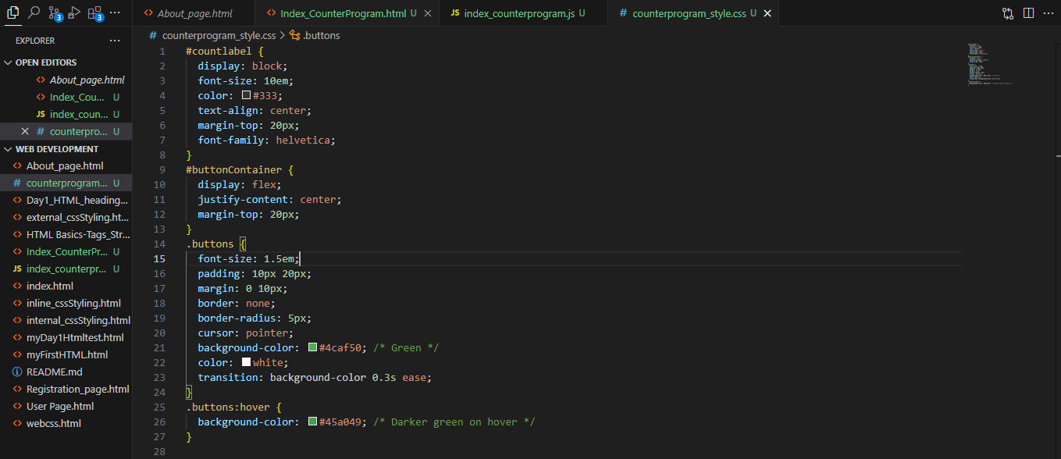

1. **index_counterprogram.js**

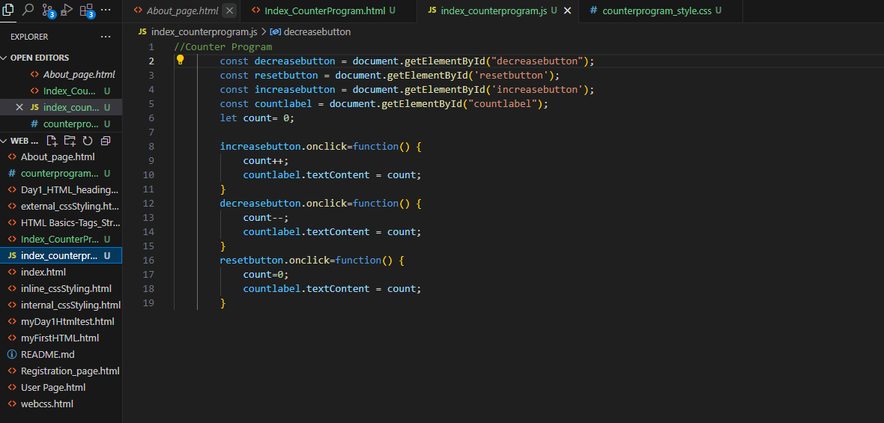

1. **Output**

